SPREADSHEETS

A spreadsheet is a table of values arranged in rows and columns. Rows are typically labelled using numbers (1, 2, 3, etc.), while columns are labelled with letters (A, B,
C, etc). Individual row/column locations, such as C3 or B12, are referred to as cells. Each cell can each store a unique instance of data. By entering data into a spreadsheet, information can be stored in a more structured way than using plain text. The row/column structure also allows the data to be analyzed using formulas and calculations.

For example, each row of a spreadsheet may store information about a person who has an account with a certain company. Each column may store a different aspect of the person's information, such as the first name, last name, address, phone number, favourite food, etc. The spreadsheet program can analyze this data by counting the number of people who live in a certain zip code, listing all the people whose favourite food is fried veal, or performing other calculations. In this way, a spreadsheet is similar to a database.

Spreadsheet applications (sometimes referred to simply as spreadsheets) are computer programs that let you create and manipulate spreadsheets electronically. In a spread sheet application, each value sits in a cell. You can define what type of data is in each cell and how different cells depend on one another. The relationships between cells are called formulas, and the names of the cells are called labels.

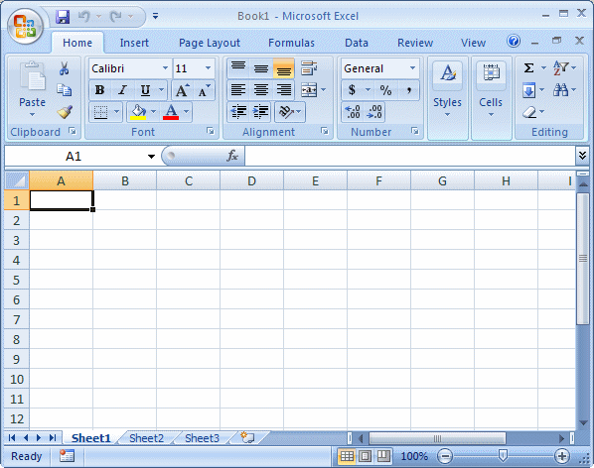
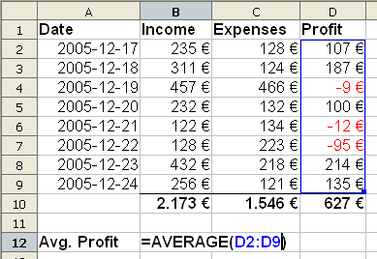
Microsoft Excel is one of the most common spreadsheet programs for Windows and Macintosh computers. It is part of the Microsoft Office suite, which includes other productivity programs, such as Word and PowerPoint.
A Spreadsheet
The Excel Program used to create spreadsheets.

